LCMS International Mission Central Sharing the Light of Christ’s Love
$ 5,000
Support for multimedia resources for Johanna Heidorn in spreading the Gospel, planting churches, and showing mercy in Latin America and the Caribbean

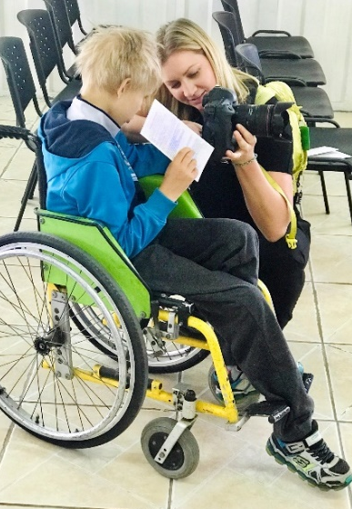
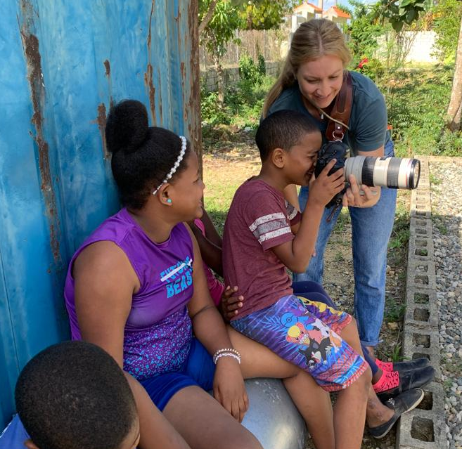

I consider it a great privilege to work alongside ladies with such zeal to serve God. With your support and dedication, you make a tangible difference in spreading the Gospel, planting Lutheran churches, and showing mercy to the countries just to the south of us. This grant is a partnership in mission as you, the women of the LWML Washington-Alaska District, become part of the story in Latin America and Caribbean.

2022-2024 Biennium – LWML Washington-Alaska District

